**E -PHARMACY MANAGEMENT**

**BJS**

Bharatiya jain sanghatana

**A**

**Project Report On**

**“E- PHARMACY MANAGEMENT”**

**Submitted to**

**SAVITRIBAI PHULE UNIVERSITY**

**In partial fulfilment of the Requirement of**

Bachelor of Business Administration

(Computer Application)

(Semester – IV)

**Submitted By**

**SAMADHAM UTTAM BABAR**

**SAURABH SUBHASH GAIKWAD**

**Under the guidance of**

Prof. H. P. Jagtap

**BHARATIYA JAIN SANGHATANA’S**

**Arts, Science & Commerce College, Wagholi, Pune 412207**

**DEPARTMENT OF B.B.A (C.A)**

**CERTIFICATE**

**This is to certify that**

**Mr. Samadhan Uttam Babar & Mr. Saurabh Subhash Gaikwad of class B.B.A (C.A) (Semester-VI) have Completed the project work on “E-PHARMACY MANAGEMENT” Under my guidance & supervision in satisfactory manner for the Practical Fulfilment of BBA- CA (SEM VI) examination for the academic year 2021-2022.**

**Dr. Desarda K. S. Major Dr.Ashok Giri**

**(Incharge) (Principal of college)**

**Project Guide Internal Examiner External Examiner Prof. H. P. JAGTAP**

**Date: Place:**

**ACKNOWLEDGEMENT**

I hear by declare that mini project titled “E-learning management system” has been submitted to the department of BBA(CA) BJS College Wagholi, Pune

-412207 for the fourth semester BBA(CA) degree, is a record of original work done by me under the supervision and guidance of prof. Sayli, prof. Kalyani and we are also thankful to all teachers and staff member of our department for their kind co-operation and help.

We are also grateful to respected (HOD) and to our respected principle for permitting us to utilized all the necessary facities of the collage.

Place- Pune

Date- Student Signature

Nikhil Gupta

|  |  |  |
| --- | --- | --- |
| **Sr.**  **No.** | **Particular** | **Page**  **No.** |
| 1. | INTRODUCTION   1. Motivation 2. Problem Statement 3. Purpose, Objectives, Goals 4. Litrature Survey 5. Project scope and limitation |  |
| 2. | SYSTEM ANALYSIS   1. Existing System 2. Scope & limitation of existing system 3. Project Features 4. Requirement analysis    1. Functional requirement    2. Performance requirement    3. Security requirement |  |
| 3. | SYSTEM DESIGN   1. Design Constants 2. System Model (DFD) 3. Data Model (ERD) 4. User Interface |  |
| 4. | IMPLEMENTATION DETAIL   1. Software and hardware specification |  |
| 5. | OUTPUT AND REPORT TESTING   1. Test plan 2. Data validation test case |  |

**INDEX**

|  |  |  |
| --- | --- | --- |
| 6. | FUTURE SCOPE |  |
| 7. | CONCLUSION |  |
| 8. | BIBILOGRAPHY AND REFERANCE |  |

**INTRODUCTION**

# Abstract:

E-learning comprises all forms of electronically supported learning and teaching. The information and communication systems, whether networked learning or not, serve as specific media to implement the learning process. E-learning fulfils the thirst of knowledge and offers online content that can be delivered for the learner at anywhere. In an era known as the society of technology and knowledge, where lifelong learning is a way of life, it is important that educational institutions have as a priority the goal of finding effective ways of providing new learning opportunities according to their environment, student characteristics, teacher training, economic crisis and advancing technology in an effort to make learning more efficient, equitable and innovative in higher education. Anytime and any age through a wide range of e- learning solution while compared with traditional learning system.

# INTRODUCRION

* **Motivation**

E-leaíning píovides students with a diffeíent oppoítunity to leaín íegaídless of wheíe they aíe and when they aíe available. In e-leaíning enviíonment, students aíe able to paíticipate in self-faced and inteíactive leaíning that is otheíwise impossible. ľhis papeí shows that the use of inteíactive featuíes of e-leaíning incíeases the motivation of undeígíaduate students foí the leaíning píocess. Inteínet technologies píovide integíated enviíonment foí web-based leaíning tools to suppoít e-leaíning education.

# Problem Statement

1. Students inability to grasp the concept and Key words.
2. Too much focus on presentation, little time Left for practice.
3. Lack of motivational push.

# Purpose, Object, Goal:

In this new era of electronics, we know the concept of e-learning which does not include the use of paper and pen. There are many advantages of e-learning system. In this e-learning system we can assign projects to students and can share documents and more easily.

This system has three modules including student, faculties and Admin. Students can login, they have access to main menu, calendar, projects, documentation, to upload, view the things uploaded by the faculties, knowledge books, also send messages to faculties. Faculties can login and have access for viewing, uploading documents and projects. Admin can login and manage the faculties and student details and also view projects. This is how the new concept of e- learning came into existence, which is an easier and smarter system for colleges.

# Project Scope

* + The main purpose of education is to achieve upward mobility. Online courses certification programs have been able to provide inexpensive education to the masses and also save time, energy and money.
  + Electronic-learning through certified online courses provides a wide range of courses that caters to the core interests of the student, thus creating a fertile arena for future advancement.
  + corporate organizations in India are recognizing the high skill levels of students who have undergone online courses certification programs from highly acclaimed educational institutions.

# Limitation:

* + Lack of face to face interaction.
  + Cheating is unavoidable.
  + Lack of self-discipline distraction.

# SYSTEM ANYLISIS

* **Existing System**

E-learning has been introduced to empower learners to get basic schooling and enhance skills. Also, they can obtain a degree certificate, without actually attending school or university or any other institution. For tutors, it is a great source of earning, wherein they can teach from anywhere in their preferred time. Applying e- learning to all levels of schooling helped to ensure students grasp the lessons adequately at a faster pace. According to psychology, the audio-visual method of teaching leads to a disciplined learning environment.

# Scope And Limitation of existing System

The use of online learning provides solutions that can overcome some problems with traditional education, especially in the area of medicine.

With increasing constraints being placed on educators, one need to explore other avenues foe effective knowledge transfer to trainees. E- learning provides flexibility in both time and location, while accessing curriculums presented online

# Project Features

* Anytime, anywhere, anyone can use the e- learning management system.
* Effective learning it enhance the ability to learn and implement the new process and knowledge at the workplace.
* Friendly easy using, e-learning is easy to use and enables learner to take a control and find what they need quickly.
* Personalized learning, the content speaks directly to the learner as individual rather than addressing the learning audience as a group.
* Less impact on environment, e-learning is a paperless way of learning, it protects the environment to a lot of extents, there is no need to cut trees for obtaining paper.
* Self registration, online students examine your online course inventory and locates the perfect e-learning course for their requirement.

# Requirement Analysis:

Much of the initial focus of the research has been on software side of e-learning. However, recently the hardware and the technology of delivering have been getting more attention in the form of mobile learning. **Reseaícheís seem to agíee that the use of tablets has potential that is undeíutilized in academia. ľhe team íeviewed publications of expeíiments on the use of tablets in higheí education identifying some key findings. Fíom these findings, the team has developed system íequiíements foí the design of a puípose-built educational tablet foí higheí education. ľhese findings include selecting tablets that would miííoí the institution's own computeí lab designs, including the opeíating system, educational applications, as well as íestíicting use of cameía and íestíicting download of none- educational applications and apps.**

# SYSTEM DESIGN

* **Design constraints:**

**ľhis píoject is conceíned with the analysis, design, development, implementation and evaluation of an e- leaíning management system to píovide a useí fíiendly enviíonment foí píospective students to acquiíe knowledge at any educational level and to bíidge the gap between teacheís and students.**

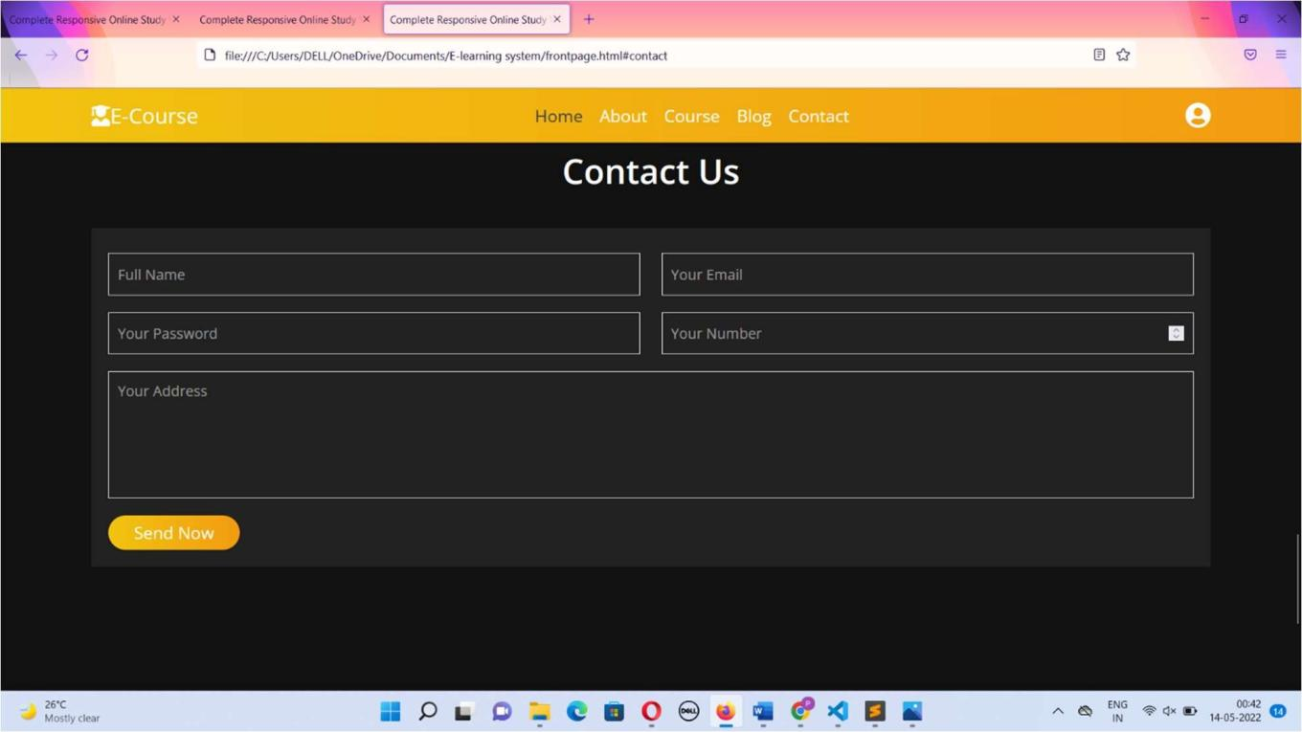

# User Interface

**Useí inteíface (UI) design of e-leaíning is a point of inteíaction between useí and computeí softwaíe.**

**Useís píefeí moíe attíactive and simpleí inteíface designs íatheí than dull oí complex designs. ľhis study aims to outline the impact of UI design on the satisfaction of leaíneís.**

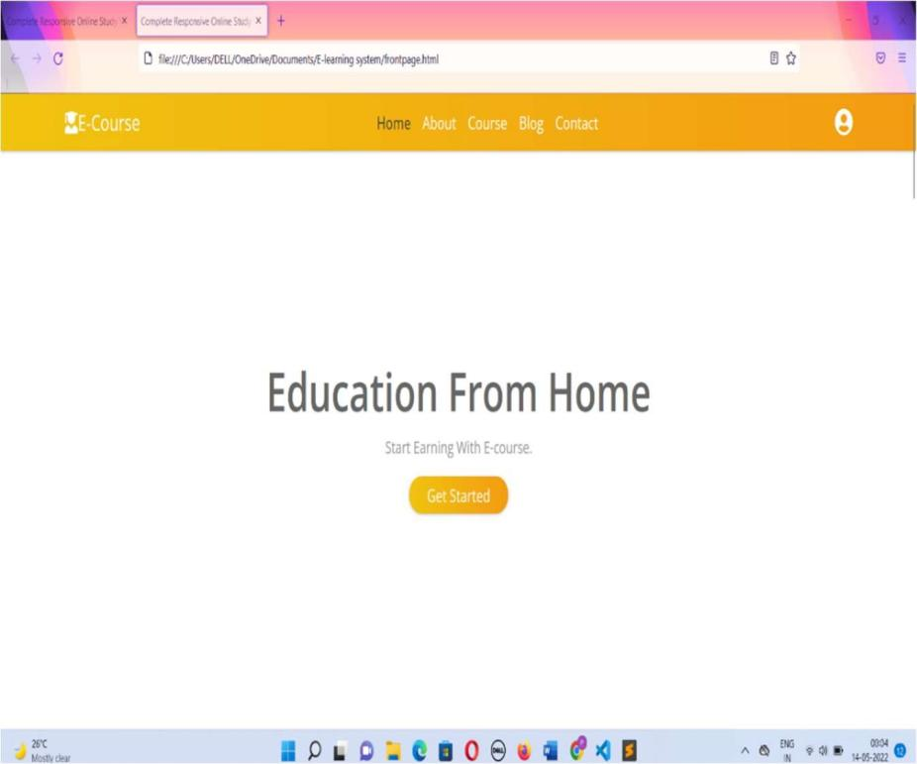

# IMPLEMENTATION DETAIL

* **Software specification:**

**Operating system:** Microsoft windows 2011.

**Frontend:** Sublime text 3.

# Hardware specification:

**Processer:** 11th Gen Intel(R) Core(TM) i3-1125G4 @ 2.00GHz

**Hard disk:** Minimum 119 GB

**RAM:** 8.00 GB.

# FUTURE SCOPE

1.E-learning has a great scope in the future as well. It is a well-known fact that the purpose of education is to attain upward mobility. With the help of online education, the masses have been able to access inexpensive education, and save ample time, money and energy.

1. Earlier, there was a misconception that recruiters only hire those candidates who have completed various programs from reputed universities. However, it has been observed that they go behind candidates who have completed several certification programs online.
2. A lot of times, students do not get the desirable courses in colleges and universities. On the other hand, nowadays, students are getting flexible options to opt for core courses that best suit their interests online.

# CONCLUSION

E-learning is not just a change of technology. It is part of a redefinition of how we as a species transmit knowledge, skills, and values to younger generations of workers and students. This book makes a few predictions of how e- learning and the functions it serves will continue to develop. Learners will have access to millions or billions of knowledge modules. Some will be Web pages with simple text and graphics.

Others may include multimedia simulations. In many fields, e-learning has become the default way to conduct training or to provide education. There are four secrets of e-learning. The first secret is to teach what learners need to learn in the way they most naturally learn. The second secret is to define clear learning objectives. The third secret builds on the first two.

# BIBLIOGRAPHY

During the development of E-learning project, We have gone through the following books and websites.

**Books:-**

* HTML, JavaScript.
* HTML using CSS

**Websites:-**

* Www.Google.com
* Www.W3schools.com
* Www.pustakalaya.com